**Name**: Sam Huffer

**Student Number**: 101633177

**Unit**: COS30031 – Games Programming

**Task**: Task 2 - C++ for Programmers

**Date**: 6 August, 2019

Tasks Completed:

* Research:
  + C++ Cheat Sheet: <https://www.mokobytes.com/wp-content/uploads/2018/11/C-Cheat-Sheet.pdf>. From the look of it, it provides most of the essentials for how to do stuff in C++. I also downloaded it to the repo in the task 2 folder.
  + Online debugging tool: <http://cpp.sh/>.
  + Keyboard shortcuts for chosen editor: <http://visualstudioshortcuts.com/2017/> outlines a seemingly excessive and complete list of keyboard shortcuts for Visual Studio 2017, the IDE that I’m currently using.
* Additional resources found while completing the coding exercise:
  + <https://stackoverflow.com/questions/4108313/how-do-i-find-the-length-of-an-array> answers how to get the length of an array in C++ (by using the array class rather than C++’s built in array function.
  + <http://www.cplusplus.com/reference/cstdlib/rand/> answers how to generate random integers.
  + <http://www.cplusplus.com/forum/beginner/87238/> answers how to split strings
  + <https://www.codeproject.com/Articles/118921/C-Properties> answers how to do makeshift and proper get/set properties in C++.
* 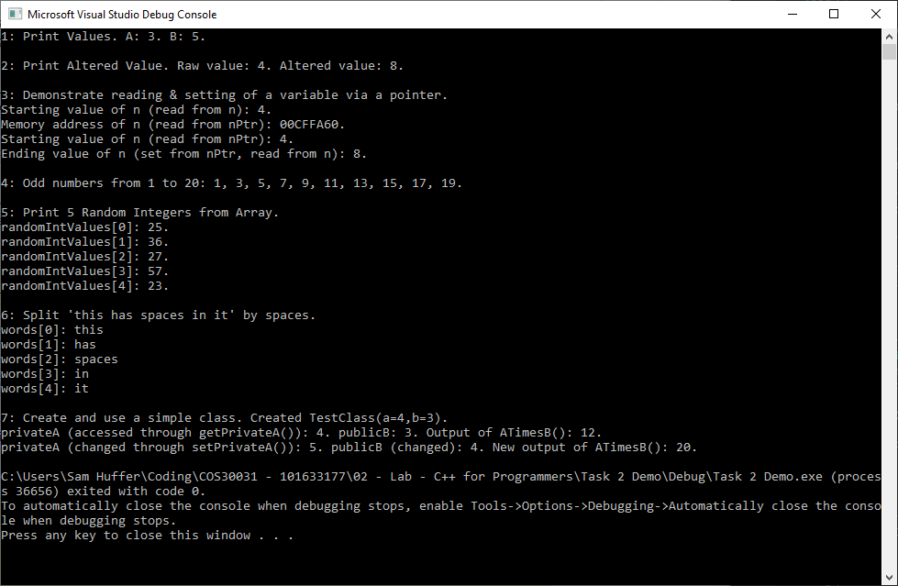Coding exercise (resulting in the following output to the terminal):